- Budget Transfer & Reallocation
- Below is the revised workflow:
- Create request – Requestor
- Submit request – Requestor to manually choose the Department Head who will approve the request
- Department Head Review – Once okay, the ticket will automatically route to SBU Finance (to define in the Admin Console)
- SBU Finance Officer Review
- SBU Finance Head Approval
- SBU Head Approval
- CFO Approval
- CEO Approval
- SBU Finance Officer Completion
- Budget Officer trigger to upload to SAP
- All requests will go through step 1 to 6, 9 to 10. Requests with amount of more than 1M to 5M will go through CFO Approval. More than 5M will go through CEO.
- Require attachment of supporting document upon request creation.
- SBU Finance Officer, SBU Finance Head, SBU Head, CFO and CEO – the users for these roles will be defined in the Admin Console.
- Allow return ticket to the requestor.
- Allow reassignment to other user which role is not in defined in the Admin Console.
- Allow cancellation of ticket.
- Revise ‘Reason’ to ‘Details’ – state what should be included in the Details box: “Brief description of the request”
- Put a comment box every approval stage.
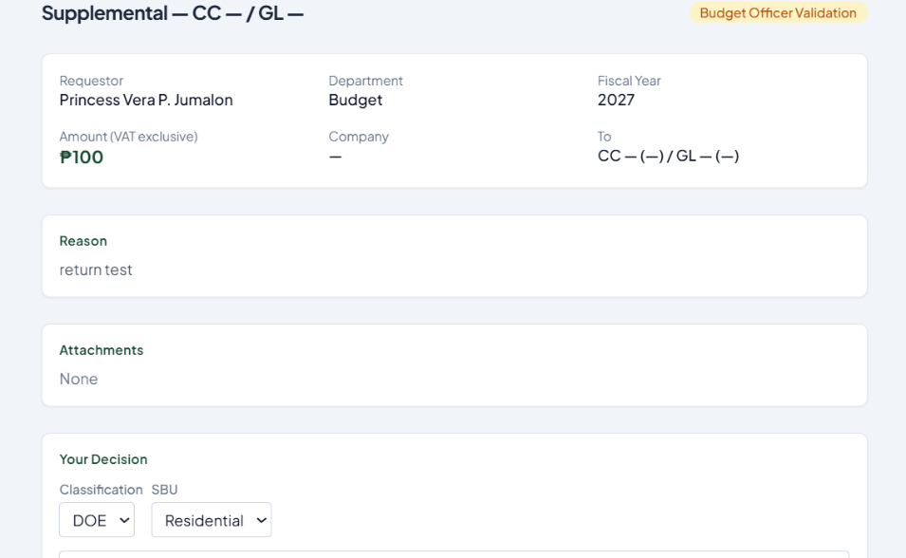
- Divide the Inbox details screen into two parts. Right side should contain the review history with audit trail. Apply also to My Transfer details screen.

- Remove this
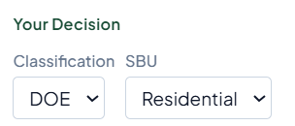
- For New Transfer creation, add a field for SBU (dropdown list), Location (dropdown list)
- For CC and GL, show also the Name once selected.
- For reallocation, once ‘To’ CC and GL are selected, show the current amount pulled from SAP. Once ‘From’ CC and GL are selected, show the planned amount once approved.
- Generate a ticket number for every request created.

